# SEGMENT 4

Segment 4: Ratings Analysis and Crew Members

* Retrieve the minimum and maximum values in each column of the ratings table (except movie_id).

* Identify the top 10 movies based on average rating.

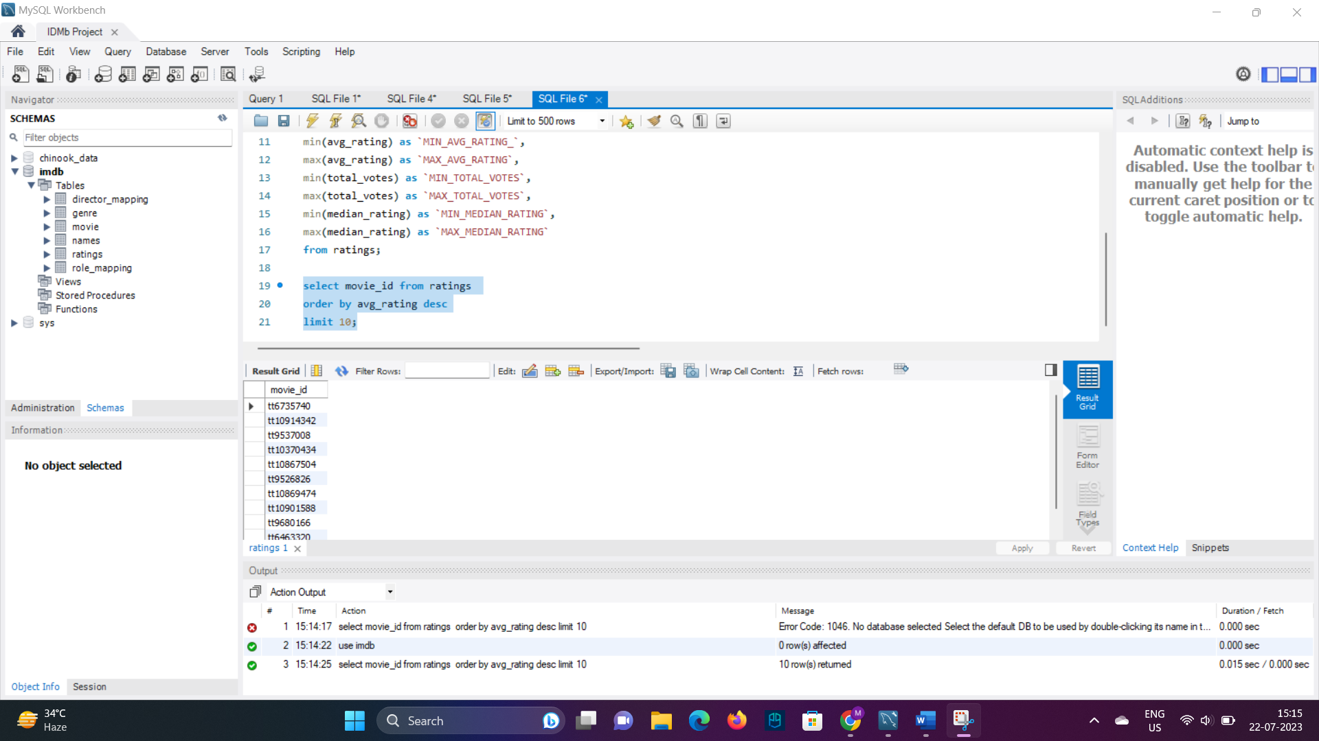

* Summarise the ratings table based on movie counts by median ratings.

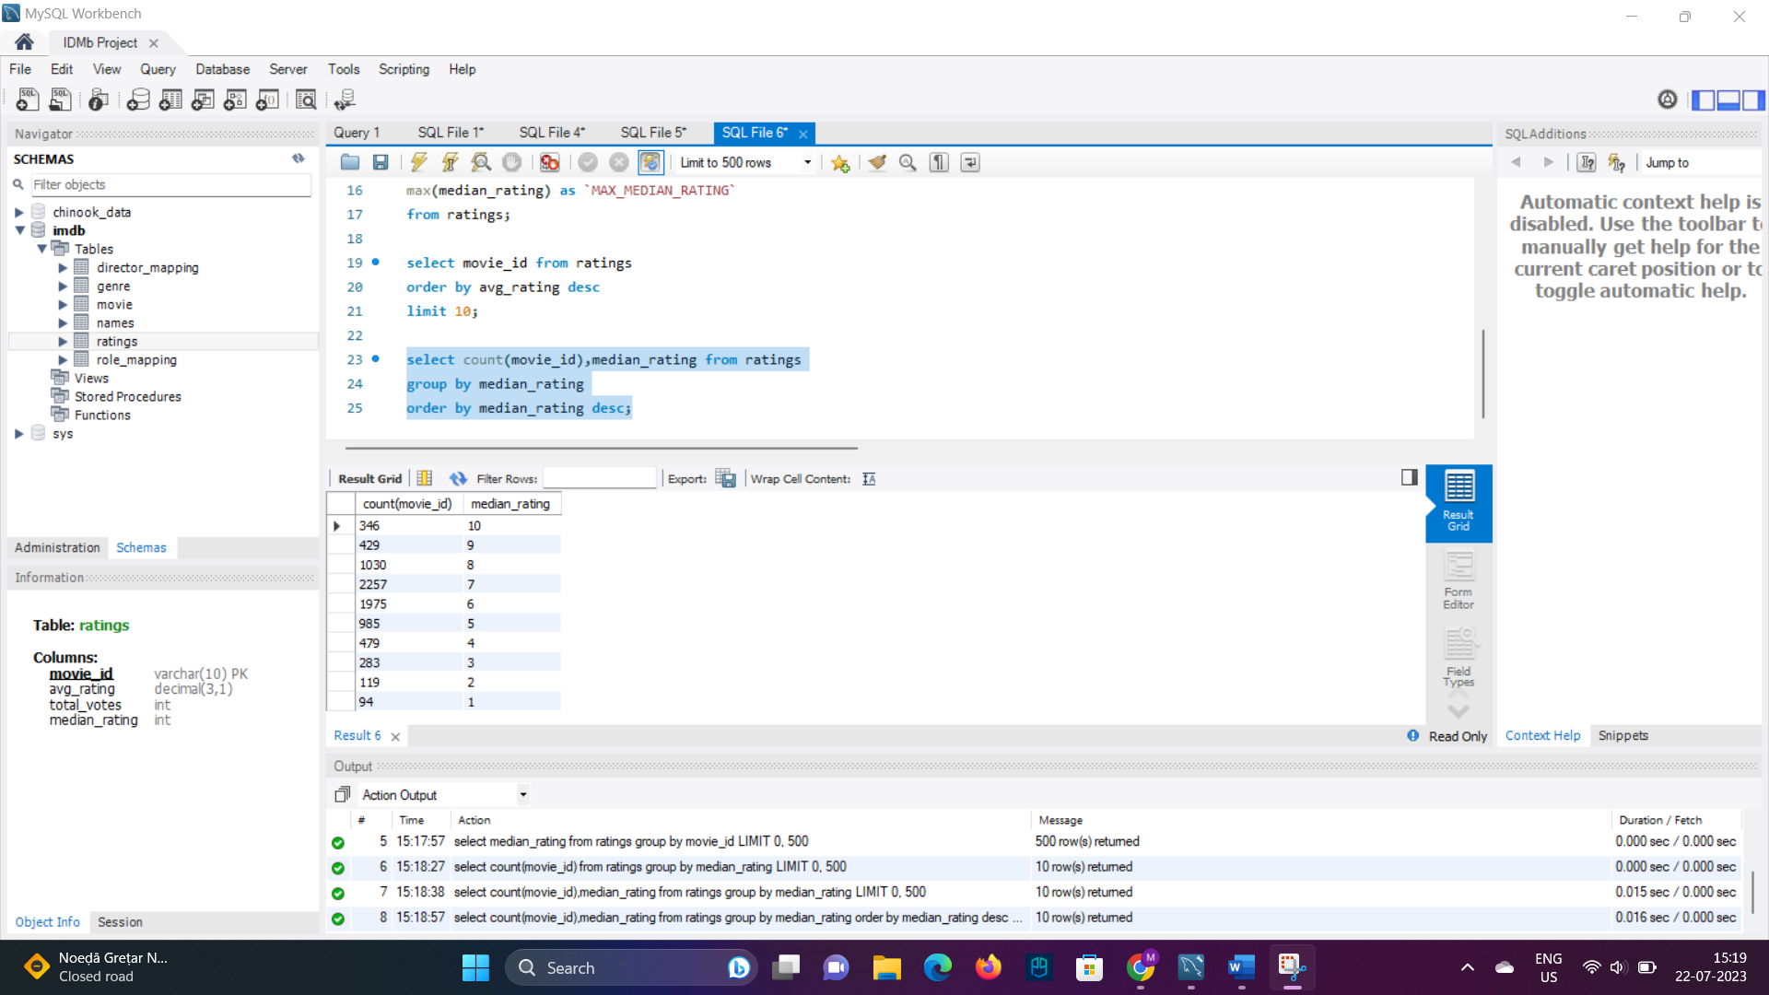

* Identify the production house that has produced the most number of hit movies (average rating > 8).

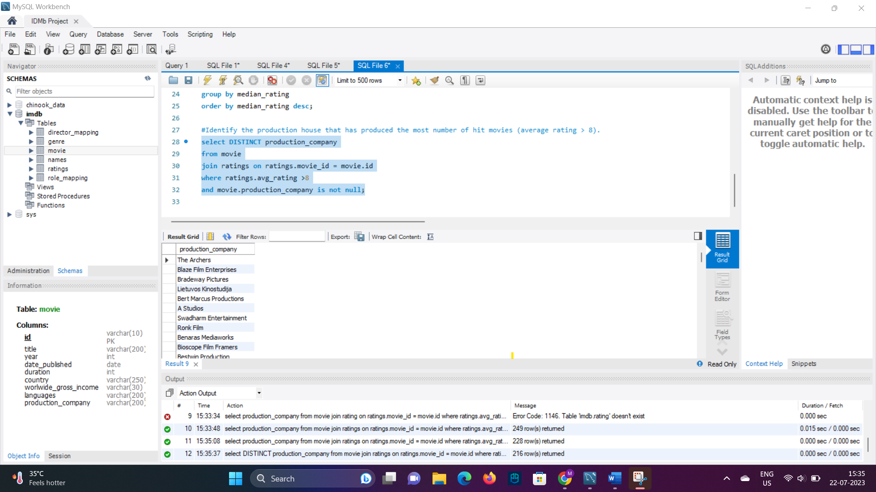

* Determine the number of movies released in each genre during March 2017 in the USA with more than 1,000 votes.

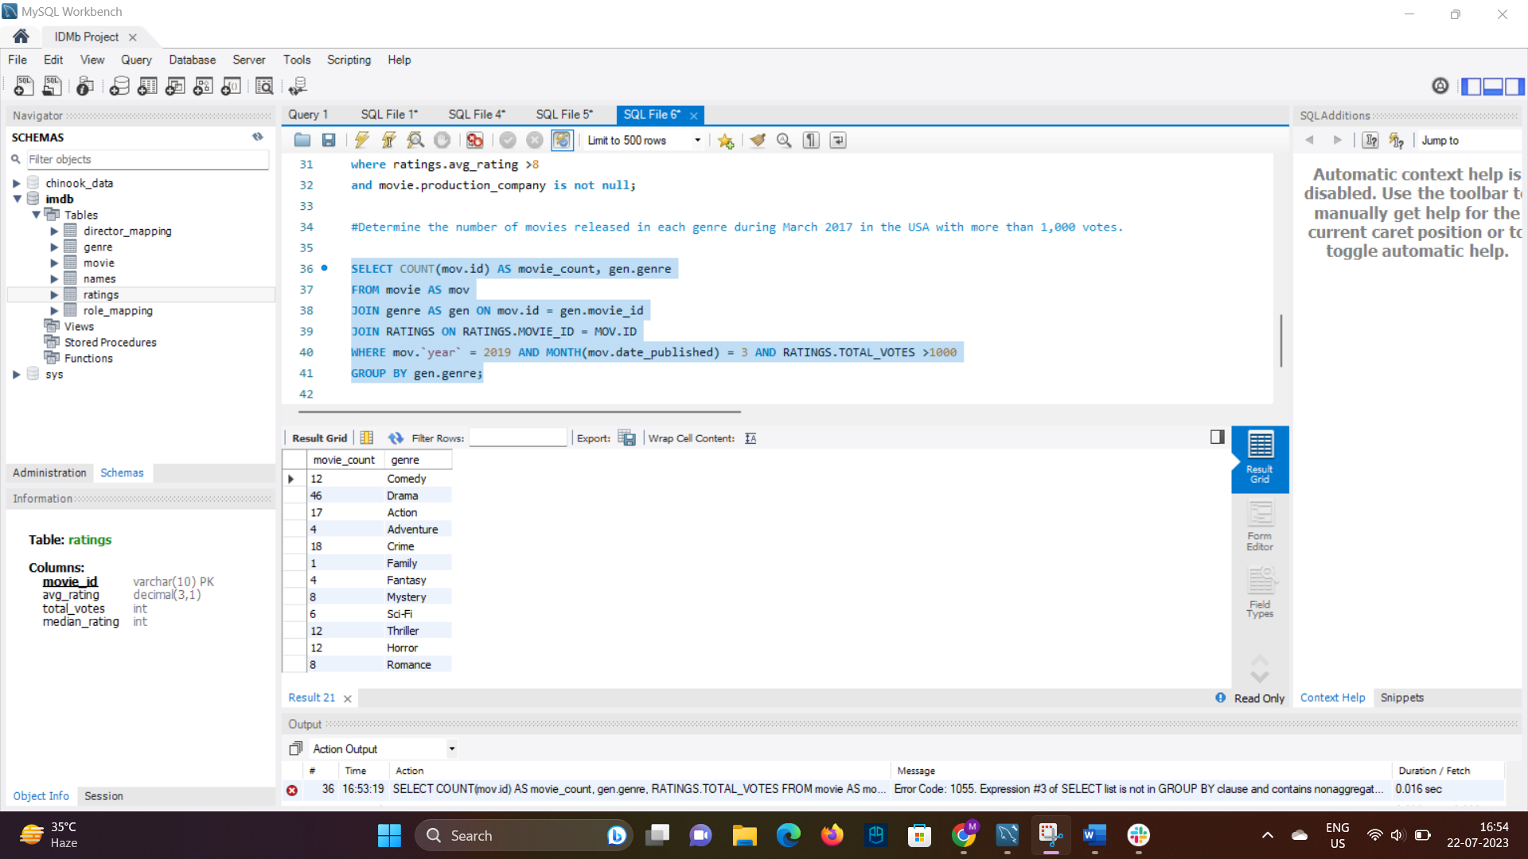

* Retrieve movies of each genre starting with the word 'The' and having an average rating > 8.

